**PROJECT ORDER RETAILERS**



DEPARTMENT OF ELECTRONICS AND COMMUNICATION ENGINEERING

Dr. B R AMBEDKAR NATIONAL INSTITUTE OF TECHNOLGY JALANDHAR- 144011, PUNJAB (INDIA)

Name-Navneet Singh

Branch - Electronics &Communication Engineering

**SOURCE CODE**

#include<bits/stdc++.h> #include<iostream> #include<stdlib.h> #include<conio.h> #include<stdio.h> #include<process.h> #include<fstream> #include<string.h> #include<unistd.h> using namespace std; fstream fp;

//*******

// CLASSES USED IN PROJECT

//********

class product

{

int pno;//product ID char name[50];

float price, qty, tax, dis; public:

void create_product()

{

cout << "\nPlease Enter The Product No. of The Product: ";

cin >> pno;

cout << "\nPlease Enter The Name of The Product: "; fflush(stdin);

gets(name);

cout << "\nPlease Enter The Price of The Product: "; cin >> price;

cout<<"\nPlease enter the quantity of product: "; cin>>qty;

cout << "\nPlease Enter The Discount (%): "; cin >> dis;

}

void show_product()

{

cout << "\nThe Product No. of The Product : " << pno; cout << "\nThe Name of The Product : ";

puts(name);

cout << "\nThe Price of The Product : " << price; cout<<"\nQuantity available of :"<<qty;

cout << "\nDiscount : " << dis;

}

int retpno()

{

return pno;

}

float retprice()

{

return price;

}

char * retname()

{

return name;

}

int retdis()

{

return dis;

}

int getquantity(){ return qty;

}

void setquantity(int quant){ qty=quant;

}

}; //class ends here class customer{

char name[50];

char address[50]; char state[30]; int pincode;

char contact[12]; char username[50]; char password[50];

public:

void create_customer(){ cout<<"\nEnter your name: "; fflush(stdin);

gets(name);

cout<<"\nEnter your address: "; fflush(stdin);

gets(address); cout<<"\nEnter your state: "; fflush(stdin);

gets(state);

cout<<"\nEnter the pincode: "; cin>>pincode;

cout<<"\nEnter your contact no:"; fflush(stdin);

gets(contact);

cout<<"\nEnter a username: "; fflush(stdin);

gets(username); cout<<"\nEnter a password: "; fflush(stdin);

gets(password);

}

char* getusername(){ return username;

}

void show_customer(){

cout<<"The name of the customer is:"<<puts(name); cout<<"\nThe address of

"<<puts(name)<<"is"<<puts(address); cout<<"\n Pincode"<<pincode;

}

char* getpassword(){ return password;

}

};

//*******

// global declaration for stream object, object

//********

customer cp; product pr;

//*******

// function to write in file

//********

void write_product()

{

fp.open("Shop.dat", ios::out | ios::app); pr.create_product();

fp.write((char * ) & pr, sizeof(product)); fp.close();

cout << "\n\nThe Product Has Been Created "; getch();

}

//*******

// function to read all records from file

//********

void display_all()

{

system("cls");

cout << "\n\n\n\t\tDISPLAY ALL RECORD !!!\n\n"; fp.open("Shop.dat", ios:: in );

while (fp.read((char * ) & pr, sizeof(product)))

{

pr.show_product();

cout << "\n\n====================================\n";

getch();

}

fp.close();

getch();

}

//*******

// function to read specific record from file

//********

void display_sp(int n)

{

int flag = 0; fp.open("Shop.dat", ios:: in );

while (fp.read((char * ) & pr, sizeof(product)))

{

if (pr.retpno() == n)

{

system("cls"); pr.show_product(); flag = 1;

}

}

fp.close();

if (flag == 0)

cout << "\n\nrecord not exist"; getch();

}

//*******

// function to modify record of file

//********

void modify_product()

{

int no, found = 0; system("cls");

cout << "\n\n\tTo Modify ";

cout << "\n\n\tPlease Enter The Product No. of The Product"; cin >> no;

fp.open("Shop.dat", ios:: in | ios::out);

while (fp.read((char * ) & pr, sizeof(product)) && found ==

0)

{

if (pr.retpno() == no)

{

endl;

}

}

pr.show_product();

cout << "\nPlease Enter The New Details of Product" <<

pr.create_product();

int pos = -1 * sizeof(pr); fp.seekp(pos, ios::cur);

fp.write((char * ) & pr, sizeof(product)); cout << "\n\n\t Record Updated";

found = 1;

fp.close();

if (found == 0)

cout << "\n\n Record Not Found "; getch();

}

//*******

// function to delete record of file

//********

void delete_product()

{

int no; system("cls");

cout << "\n\n\n\tDelete Record";

cout << "\n\nPlease Enter The product no. of The Product You Want To Delete";

cin >> no;

fp.open("Shop.dat", ios:: in | ios::out); fstream fp2;

fp2.open("Temp.dat", ios::out); fp.seekg(0, ios::beg);

while (fp.read((char * ) & pr, sizeof(product)))

{

if (pr.retpno() != no)

{

fp2.write((char * ) & pr, sizeof(product));

}

}

fp2.close();

fp.close(); remove("Shop.dat");

rename("Temp.dat", "Shop.dat"); cout << "\n\n\tRecord Deleted .."; getch();

}

//*******

// function to display all products price list

//********

void menu()

{

system("cls"); fp.open("Shop.dat", ios:: in ); if (!fp)

{

cout << "ERROR!!! /nThere are no products in shop../nFILE COULD NOT BE OPEN\n\n\n Go To Admin Menu to create File ";

cout << "\n\n\n Program is closing ";

getch();

exit(0);

}

cout << "\n\n\t\tProduct MENU\n\n"; cout <<

"=============================================

=======\n";

cout << "P.NO.\t\tNAME\t\tPRICE\n"; cout <<

"=============================================

=======\n";

while (fp.read((char * ) & pr, sizeof(product)))

{

cout << pr.retpno() << "\t\t" << pr.retname() << "\t\t" << pr.retprice() << endl;

}

fp.close();

}

//*******

// function to place order and generating bill for Products

//********

void place_order()

{

int order_arr[50], quan[50], c = 0; float amt, damt, total = 0;

char ch = 'Y';

menu(); //first checking if there is any product in shop cout << "\n============================"; cout << "\n PLACE YOUR ORDER";

cout << "\n============================\n";

do

{

cout << "\n\nEnter The Product No. Of The Product : "; cin >> order_arr[c];

cout << "\nQuantity in number : "; cin >> quan[c];

c++;

cout << "\nDo You Want To Order Another Product ? (y/n)";

cin >> ch;

} while (ch == 'y' || ch == 'Y');

cout << "\n\nThank You For Placing The Order"; getch();

system("cls");

cout << "\n\n***** INVOICE ***\n";

cout << "\nPr No.\tPr Name\tQuantity \tPrice \tAmount

\tAmount after discount\n "; for (int x = 0; x <= c; x++)

{

fp.open("Shop.dat", ios:: in ); fp.read((char * ) & pr, sizeof(product)); while (!fp.eof())

{

if (pr.retpno() == order_arr[x])

{

amt = pr.retprice() * quan[x]; pr.setquantity(pr.getquantity()-quan[x]); damt = amt - (amt * pr.retdis() / 100);

cout << "\n" << order_arr[x] << "\t" << pr.retname()

<<"\t" << quan[x] << "\t\t" << pr.retprice() << "\t" << amt << "\t\t" << damt;

total += damt;

}

fp.read((char * ) & pr, sizeof(product));

}

fp.close();

}

cout << "\n\n\t\t\t\t\tTOTAL = " << total; getch();

}

//******

//function to add new customer

//******

void add_customer(){ system("cls");

ifstream in("Customer.dat"); customer new1;

if(in){

fp.open("Customer.dat", ios:: in); int count=0; while(count!=1){ new1.create_customer();

while (fp.read((char * ) & cp, sizeof(customer)))

{

if(strcmp(cp.getusername(),new1.getusername())==0){ cout<<"Username already exists!! Enter your details

again: "<<endl;

fp.seekg(0,ios::beg); count=0;

break;

}else{

count=1; continue;

}

}

}

fp.close();

fp.open("Customer.dat",ios::out | ios:: app); fp.write((char * ) & new1, sizeof(customer)); cout<<"\n\t Customer successfully addeded: "; fp.close();

}else{

new1.create_customer(); fp.open("Customer.dat",ios::out); fp.write((char * ) & new1, sizeof(customer)); cout<<"\n\t Customer successfully addeded: "; fp.close();

}

}

//********

//login*********

//******** int login(){ system("cls");

char username[50]; char match[50];

cout<<"Enter your username: "; fflush(stdin);

gets(username);

cout<<"\nEnter your password: "; int i;

char ch; for(i=0;i>=0;)

{

ch=getch();

if(ch!=8&&ch!=13)

{

cout<<"*"; match[i]=ch; i++;

}

else if (ch==8) // if backspace is presssed

{

cout<<"\b \b"; // moves cursor to the left print <space> again move cursor to left

i--;

}

else if(ch==13)

{

match[i]='\0'; // if enter is pressed, last character in

match[] becomes null

break; // for end of string

}

else

{

break;

}

}

fp.open("Customer.dat", ios:: in); int count=0; while(count!=1)

{

while (fp.read((char * ) & cp, sizeof(customer)))

{

if(strcmp(cp.getusername(),username)==0)

{

if(strcmp(cp.getpassword(),match)==0)

{

cout<<"\n\tLogin Successful!!! "; fp.close();

cin.get(); return 1;

}

}

}

cout<<"\n\t Invalid Username or Password!!!"; fp.close();

return 0;

}

}

//*******

// ADMINSTRATOR MENU FUNCTION

//********

void admin_menu()

{

system("cls"); char ch2;

cout << "\n\n\n\tADMIN MENU";

cout << "\n\n\t1.CREATE PRODUCT";

cout << "\n\n\t2.DISPLAY ALL PRODUCTS";

cout << "\n\n\t3.QUERY ";

cout << "\n\n\t4.MODIFY PRODUCT"; cout << "\n\n\t5.DELETE PRODUCT";

cout << "\n\n\t6.VIEW PRODUCT MENU"; cout << "\n\n\t7.BACK TO MAIN MENU"; cout << "\n\n\tPlease Enter Your Choice (1-7) ";

// ch2 = getche();

//char ch2; cin>>ch2;

switch (ch2)

{

case '1':

system("cls"); write_product(); break;

case '2':

display_all(); break;

case '3':

int num; system("cls");

cout << "\n\n\tPlease Enter The Product No. "; cin >> num;

display_sp(num); break;

case '4':

modify_product(); break;

case '5':

delete_product(); break;

case '6':

menu();

getch();

case '7':

break; default:

cout << "\a"; admin_menu();

}

}

//*******

// THE MAIN FUNCTION OF PROGRAM

//******** int main()

{

char ch; do

{

system("cls");

cout << "\n\n\n\tMAIN MENU";

cout << "\n\n\t01. IF EXISTING CUSTOMER PLACE ORDER";

cout << "\n\n\t02. NEW CUSTOMER"; cout << "\n\n\t03. ADMINISTRATOR"; cout << "\n\n\t04. EXIT";

cout << "\n\n\tPlease Select Your Option (1-4) ";

// ch = getche(); char ch; cin>>ch;

int k; switch (ch)

{

case '1':

system("cls"); k=login(); if(k){ place_order();

}

getch(); break;

case '2':

system("cls"); add_customer(); break;

case '3':

admin_menu(); break;

case '4':

exit(0); default:

cout << "\a";

}

} while (ch != '4');

}

INTERFACE

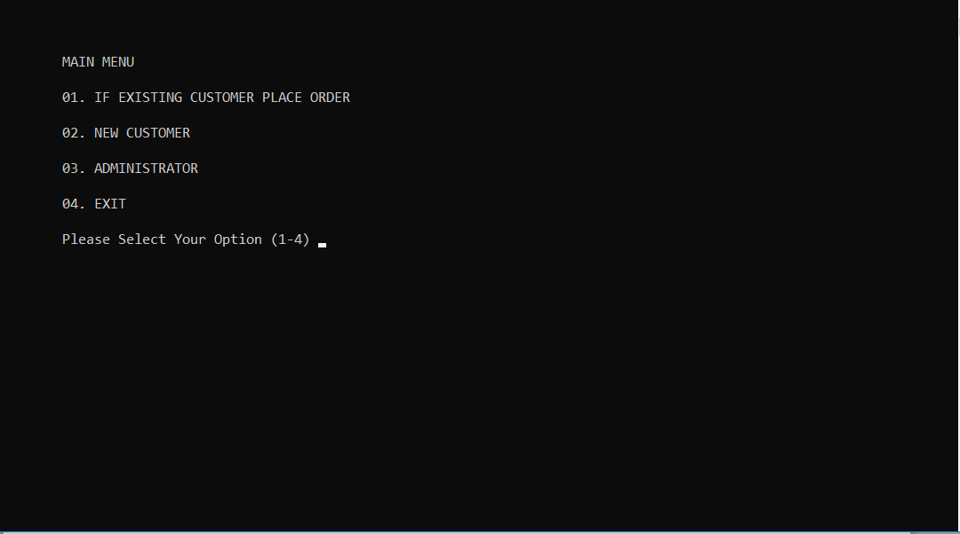

* NEW CUSTOMER

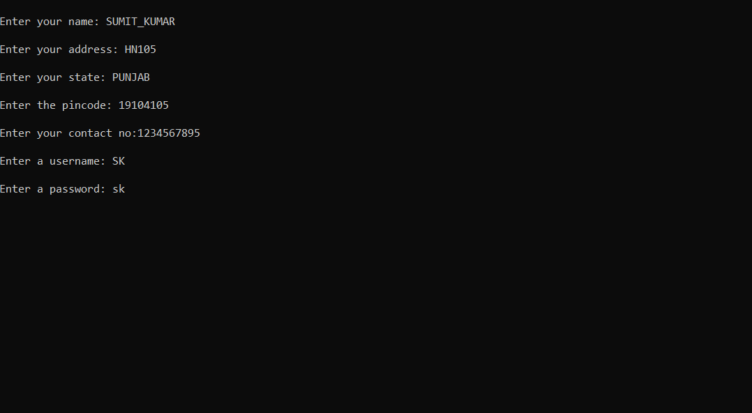

* logging in as existing user

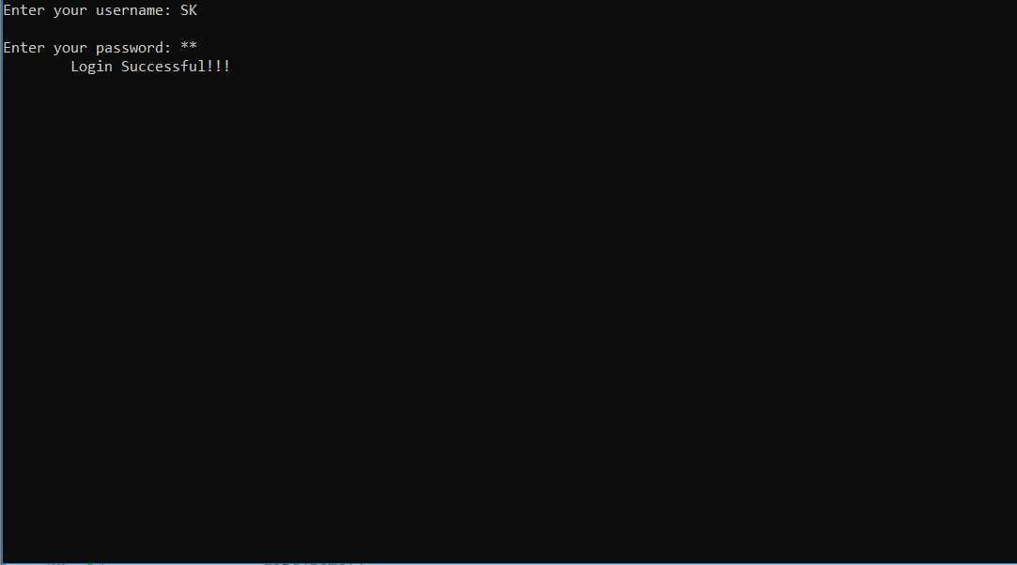

* + placing an order

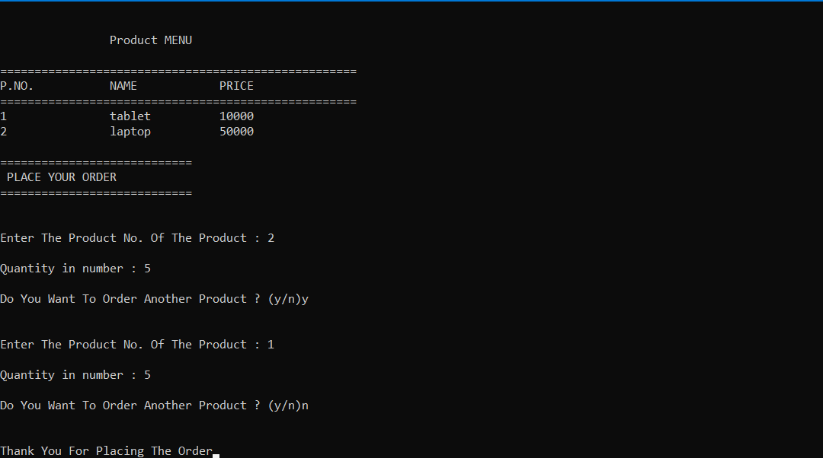

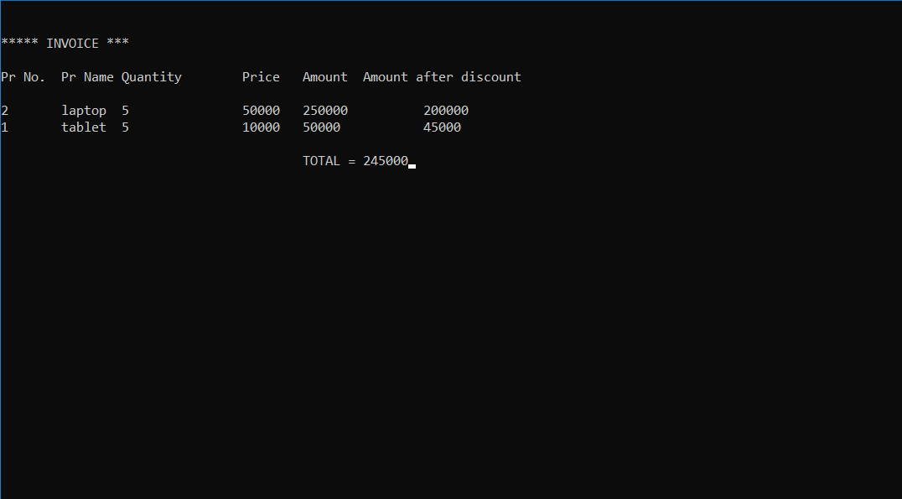

* possible Administrations:

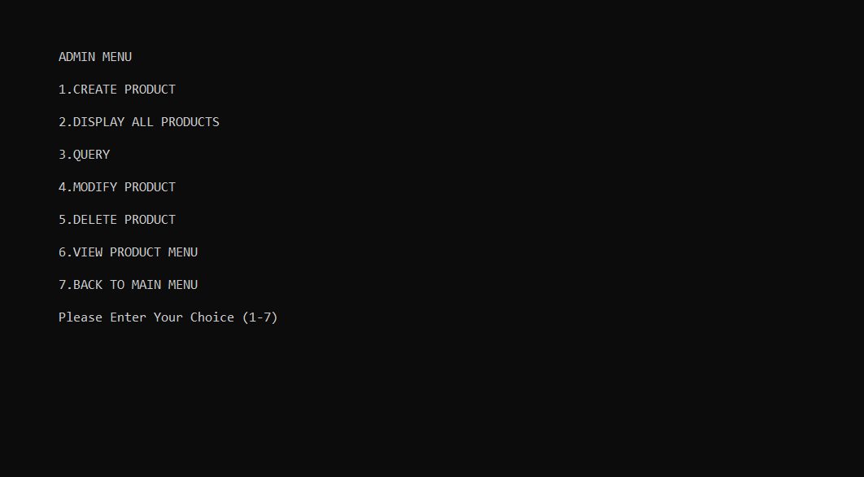

* + creating product

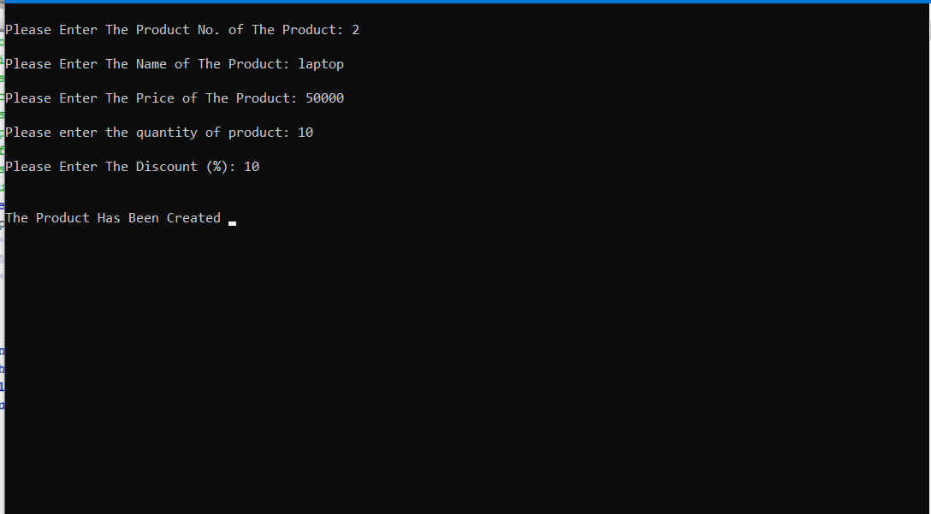

* + - display

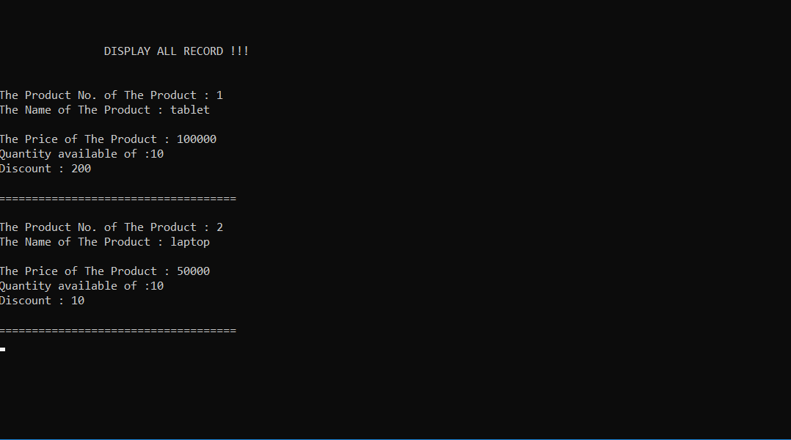

* getting product info

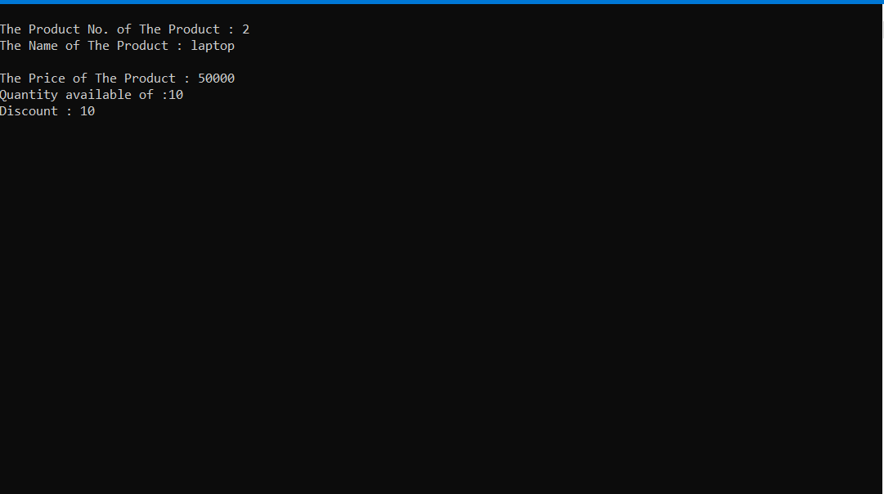

* Products before deletion

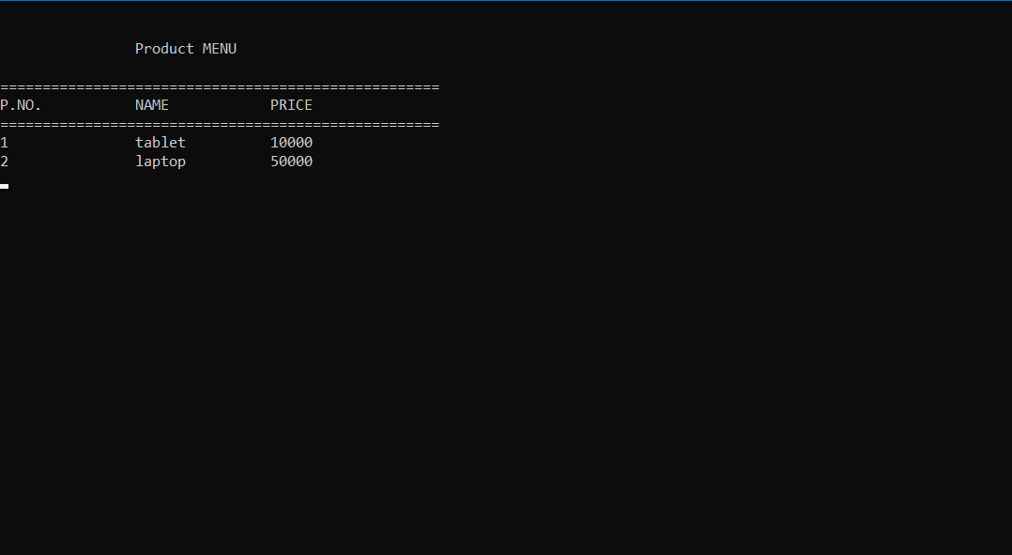

* + deleting product

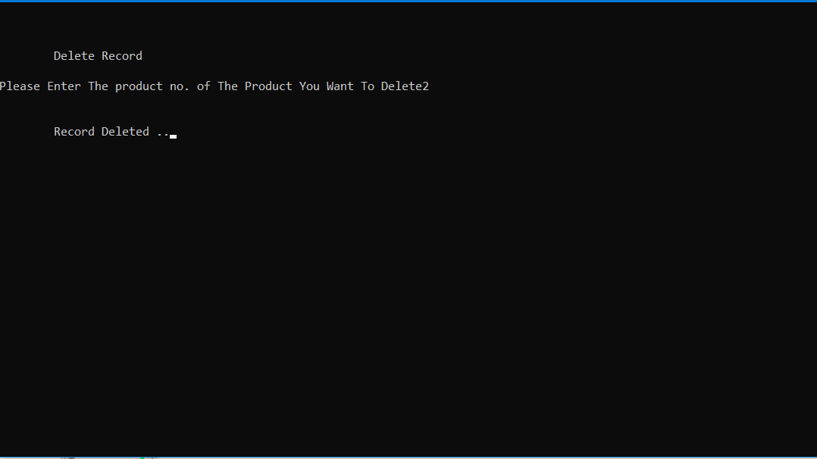

* Product menu after deletion of product no. 2

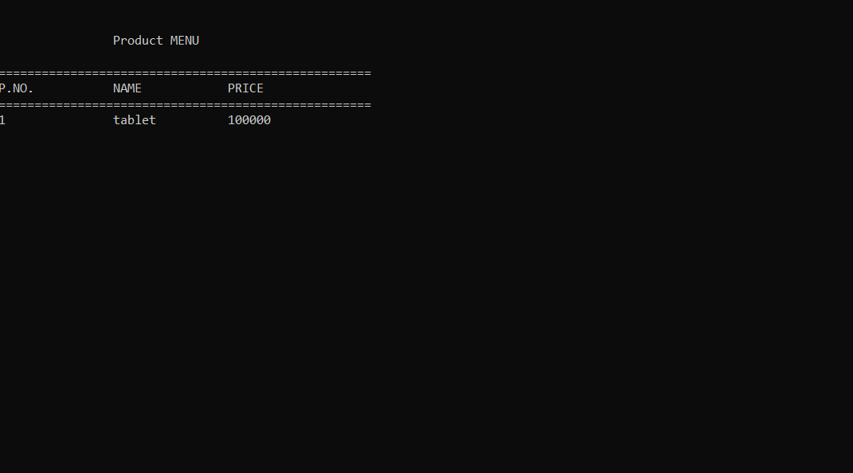

* + Modifying product

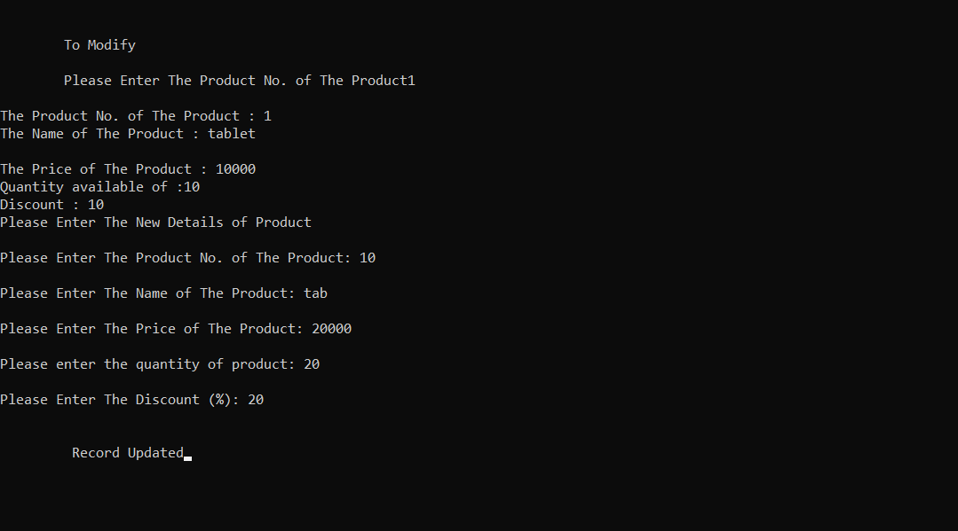

Product menu after modification

